Lecture # 15

Duties of Support to Adjacent Property Owners

- “Subjacent support”

- Subterranean owner cannot take an action that will damage the ability to make a reasonable use of the property above

- “Lateral Support”

  - (duty to avoid making uses that will damage neighbor’s reasonable use of her land)

- Strict liability for damage to neighboring land

  - Liability for damages to neighboring structures only if there is negligence

Natural Resources

General Rule: The owner of the property above a natural resource owns the underground resource

Fugitive resources (e.g. oil)

- Anybody may access the resource and take as much of it as possible, so long as they access it from their own property.

Caveats:

- The access must not interfere with the subterranean space belonging to someone else

- The digger will be strictly liable for damage to any other person’s land that is caused by negligent drilling

Oil Field Example

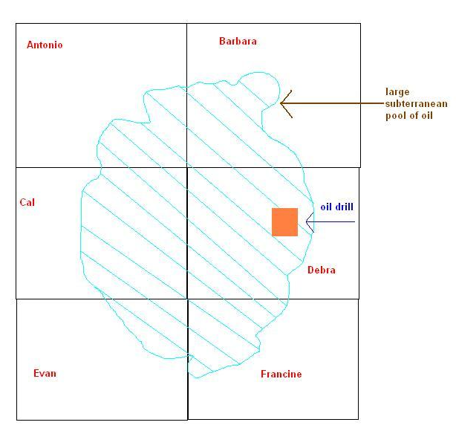

Water Rights

Watercourses

“Riparian rule”
(mostly in areas where water is plentiful)
A “riparian” (owner of property adjoining a watercourse) owns the right to that watercourse and no one can interfere with that water right.

“Prior Appropriation Rule”
(mostly in areas where water is scarce)
The state owns and apportions the right to watercourses.

Ground Water (e.g. well water)

- “Reasonable use” rule (most states)
- Some states (those with plenty of water) do not cap the usage of well water

Surface Water

- Usage: belongs to the property owner

- Diverting harmful water onto another’s property:

  - Natural Flow Rule: Cannot divert harmful water onto another property

  - Common Enemy Rule: May divert harmful water onto another property

  - Reasonable Use Rule: In between the above 2 rules

Water Rights Example

