Lecture # 13

Mortgage Theory

Lien Theory:

A mortgage is not an ownership interest;
So, one tenant taking out a mortgage does not break up a joint tenancy

Title Theory:

A mortgage not an ownership interest;
So, one tenant taking out a mortgage does break up a joint tenancy (it breaks up the unity of time by giving the mortgagee an interest in the property)

Either way, one spouse taking out a mortgage, where allowable, does not break up the tenancy by the entirety.

But, foreclosure does break up a tenancy by the entirety.

The Use of Defenses against Transferees of a Mortgage

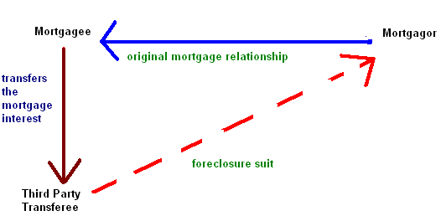

Rules:
- If Third Party Transferee is not a “holder in due course,” Mortgagor can use any defenses against Third Party Transferee that she could have used against Mortgagee
- If Third Party Transferee is a “holder in due course,” Mortgagor can use “real” defenses against Third Party Transferee, but not defenses that were personal to the Mortgagor.

What is a holder in due course?
- The transferee must have taken the mortgage in good faith (without knowledge of the defense against its enforcement)
- The transferee must have paid fair value for the mortgage

“Real” Defenses vs. “Personal” Defenses

What are “real” defenses?
- Defenses that go to the heart of the mortgage’s existence; the mortgage was never validly executed
Examples:
Forgery Incapacity

Illegality Duress

What are “personal” defenses?
Defenses that are based on the conduct of the mortgagee during the negotiations for the mortgage; the mortgage was validly executed

Examples:
Lack of consideration Unconscionability
Fraud in the Inducement

Foreclosure

Priority:
- Purchase money mortgage has first priority
- Otherwise, it’s “first in time, first in right”

Mortgage Transfers:

- Generally, a transfer of the mortgaged property does not extinguish a mortgage.
- As to question of whether transferee takes subject to the mortgage, same rules apply as with the subsequent purchasers

Effects of Foreclosure when there are multiple mortgages on the property:

- Foreclosing party’s mortgage gets paid off first
- If there is any money left, it goes to the inferior mortgages
- If there is still any money left, it goes to the mortgagee
- Inferior mortgages are extinguished
- Superior mortgages are not paid off, but are not extinguished

