Lecture # 12

Recording System

Functions:

- A way to research whether your seller has title to the property he is trying to sell you

- A way to prove your receipt of the deed against later claims by the seller

- A notification to the public of liens on a parcel of land

Indexes:

Grantor-Grantee Index:

- Lists the history of grantors alphabetically and the history of grantees alphabetically
As a buyer, you want to see your seller in the grantor index, but not in the grantee index

Tract Index:

- Lists the conveyance histories of each parcel
The Recording Acts

Notice Statute:

“No conveyance is valid against a subsequent bona-fide purchaser who has no notice of the original conveyance, unless the conveyance is first recorded.”

[The first purchaser’s deed has to be recorded before the second purchase to defeat the second good faith purchaser]

Race-Notice Statute:

“No conveyance is valid against a subsequent bona-fide purchaser who has no notice of the original conveyance and who has recorded the deed to his conveyance first.”

[To prevail, the second purchaser must be a bona-fide purchaser and must record his deed before the first purchaser does his]

Race Statute:

Whichever party records first wins!

The Problem of the Dirty Double Dealer

Scenario 1

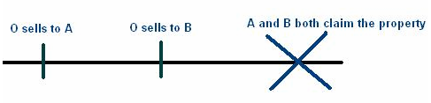

Rules:

Common Law: A would win

Modern Law: If no recording system is available, A wins

If there is a recording system, it depends who recorded first

The Problem of the Dirty Double Dealer

Scenario 2
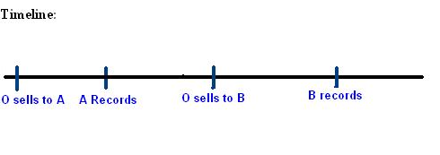
Irrelevant whether B knew about the conveyance to A!!

A Wins in all jurisdictions because:

- (in notice jurisdictions) B is not a bona-fide purchaser because he should have researched and known about the conveyance from O to A before he bought it)
- (in race-notice jurisdictions) A recorded first and because B is not a bona-fide purchaser
- (in race jurisdictions) A recorded first
The Problem of the Dirty Double Dealer

Scenario 3
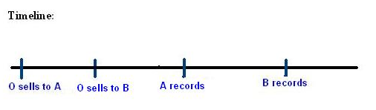

B did not know about the conveyance to A!!

Who wins?

- In notice jurisdictions B wins because B is a bona-fide purchaser who bought the property without notice of the prior sale
- In race-notice jurisdictions: A wins because A recorded first
- (in race jurisdictions) A wins because A recorded first

The Problem of the Dirty Double Dealer

Scenario 4

B did know about the conveyance to A!!

Who wins?

- In notice jurisdictions A wins because B is not a bona-fide purchaser because B did not buy the property in good faith

- In race-notice jurisdictions: A wins because A recorded first and because B is not a bona-fide purchaser

- (in race jurisdictions) A wins because A recorded first
The Problem of the Dirty Double Dealer

Scenario 5



B did not know about the conveyance to A!!

Who wins?

- In notice jurisdictions B wins because B is a bona-fide purchaser who bought the property in good faith

- In race-notice jurisdictions: B wins because B recorded first

- (in race jurisdictions) B wins because B recorded first

The Problem of the Dirty Double Dealer

Scenario 6

B did know about the conveyance to A!!

Who wins?

- In notice jurisdictions A wins because B is not a bona-fide purchaser

- In race-notice jurisdictions: A wins because B is not a bona-fide purchaser

- (in race jurisdictions) B wins because B recorded first

