The Probate Proceeding

- Step 1: Gather all relevant information and documents; i.e. Wills, Trusts etc.

- Step 2: Fill out a probate petition.

- Step 3: Send out notices to all interested parties that they have a right to contest the Will and/or Trusts at a hearing and ask them to sign a waiver of this right.

- Step 4: (hopefully) Get all the waivers in order and send them into the probate court.
OR
- Step 4A: Hold any Will contest hearings that need to be held.

- Step 5: Get “letters testamentary” that “admit” the Will to probate and officially appoint Executor or Administrator. These can also appoint guardians for minors.

- Step 6: Fill out a preliminary estate tax form with an estimate of how much will be due and pay that amount.

- Step 7: Gather and/ or account for all decedent’s assets (may have to be done by a professional bookkeeper or accountant).

- Step 8: Pay off any debts owed by the decedent and/or expenses incurred by the estate.

- Step 9: Calculate and pay estate tax (or get a refund from what was paid in step 6).

- Step 10: Pay out the assets in accordance with the Will and/or Trusts and/or the rules of intestacy.

- -Step 11: Close the estate by showing the probate court that everything called for by the estate plan has been accomplished.

The Probate Proceeding - Jurisdiction

- Governed by the law of each individual state (some states have adopted the Uniform Probate Code in whole or in part)
- States have special courts that handle the probate proceeding (e.g. “Surrogate’s Court”)

Jurisdiction by State:

- Any state in which the decedent is domiciled or a resident of has jurisdiction over the estate

- Any state has jurisdiction over real property within its borders even if the decedent was not a resident of that state

- Two or more states can sometimes have probate jurisdiction over a person if both states claim the decedent as a resident (Dorrance case). BUT, watch out for due process concerns if a state overreaches in this manner.

Will Contests

Bases for a Will Contest:

- Forgery
- Lack of testamentary intent (i.e. mistake as to the nature of the document)
- Lack of testamentary capacity
- Fraud
- Undue influence

“No contest” (“in terrorem”) clause:

The clause states that anyone who challenges the Will is automatically disinherited (as a means to discourage challenging the Will).

Of course, if the Will is successfully challenged, the whole thing, including the in terrorem clause is invalid. The only thing you really must not do is challenge the Will and lose

Some states do not allow in terrorem clauses to be effective if the challenge was in good faith
Personal Representative for an Estate

Executor (if there is a Will) Administrator (if no Will):

Order of Appointment:

[“Competence” is required of any Representative. One of the things that needs to be shown in the probate proceeding is competence of the representative.]

- The person named in the Will as Executor

- Surviving spouse; so long as he or she is a beneficiary under the Will

- Another beneficiary under the Will

- Surviving spouse that’s not a beneficiary

- Another natural heir who is not a beneficiary

- A Creditor of the estate

Other issues relevant to representatives:

- Authority: Usually very broadly defined in the Will, but limited by law (e.g. representative usually cannot make risky investments or start businesses with the estate funds)

- Duty of loyalty (no “self dealing”) to the estate

- Duty of care

- Can be personally liable for the contracts he enters into on behalf of the estate unless the contracts are specifically drafter to avoid such liability

Collecting Debts from an Estate

Nonclaim statutes

- Limit the time an unsecured creditor has to file a claim against an estate.
The purpose is to have the Executor pay off the debt before the distribution. After the distribution, it would be a mess figuring out which heir has to pay what to satisfy the debt.

- Some states apply this rule to contingent claims, some do not

- For secured loans, the creditor can maintain the security interest or accelerate the debt and call for immediate payment. Either way, the Executor must have the option to pay off the debt so that the distribution of the estate funds can be cleaner.

Order of payment of claims where the estate can’t afford to pay them all:
- Administration expenses;
- Funeral expenses and expenses of last illness (up to a stated dollar amount);
- Family allowance;
- Debts given preference under federal law, such as tax claims;
- Secured claims (up to the value of the security interest);
- Judgments entered against the decedent during his lifetime; and
- All other claims, such as unsecured creditors.

Letters Testamentary

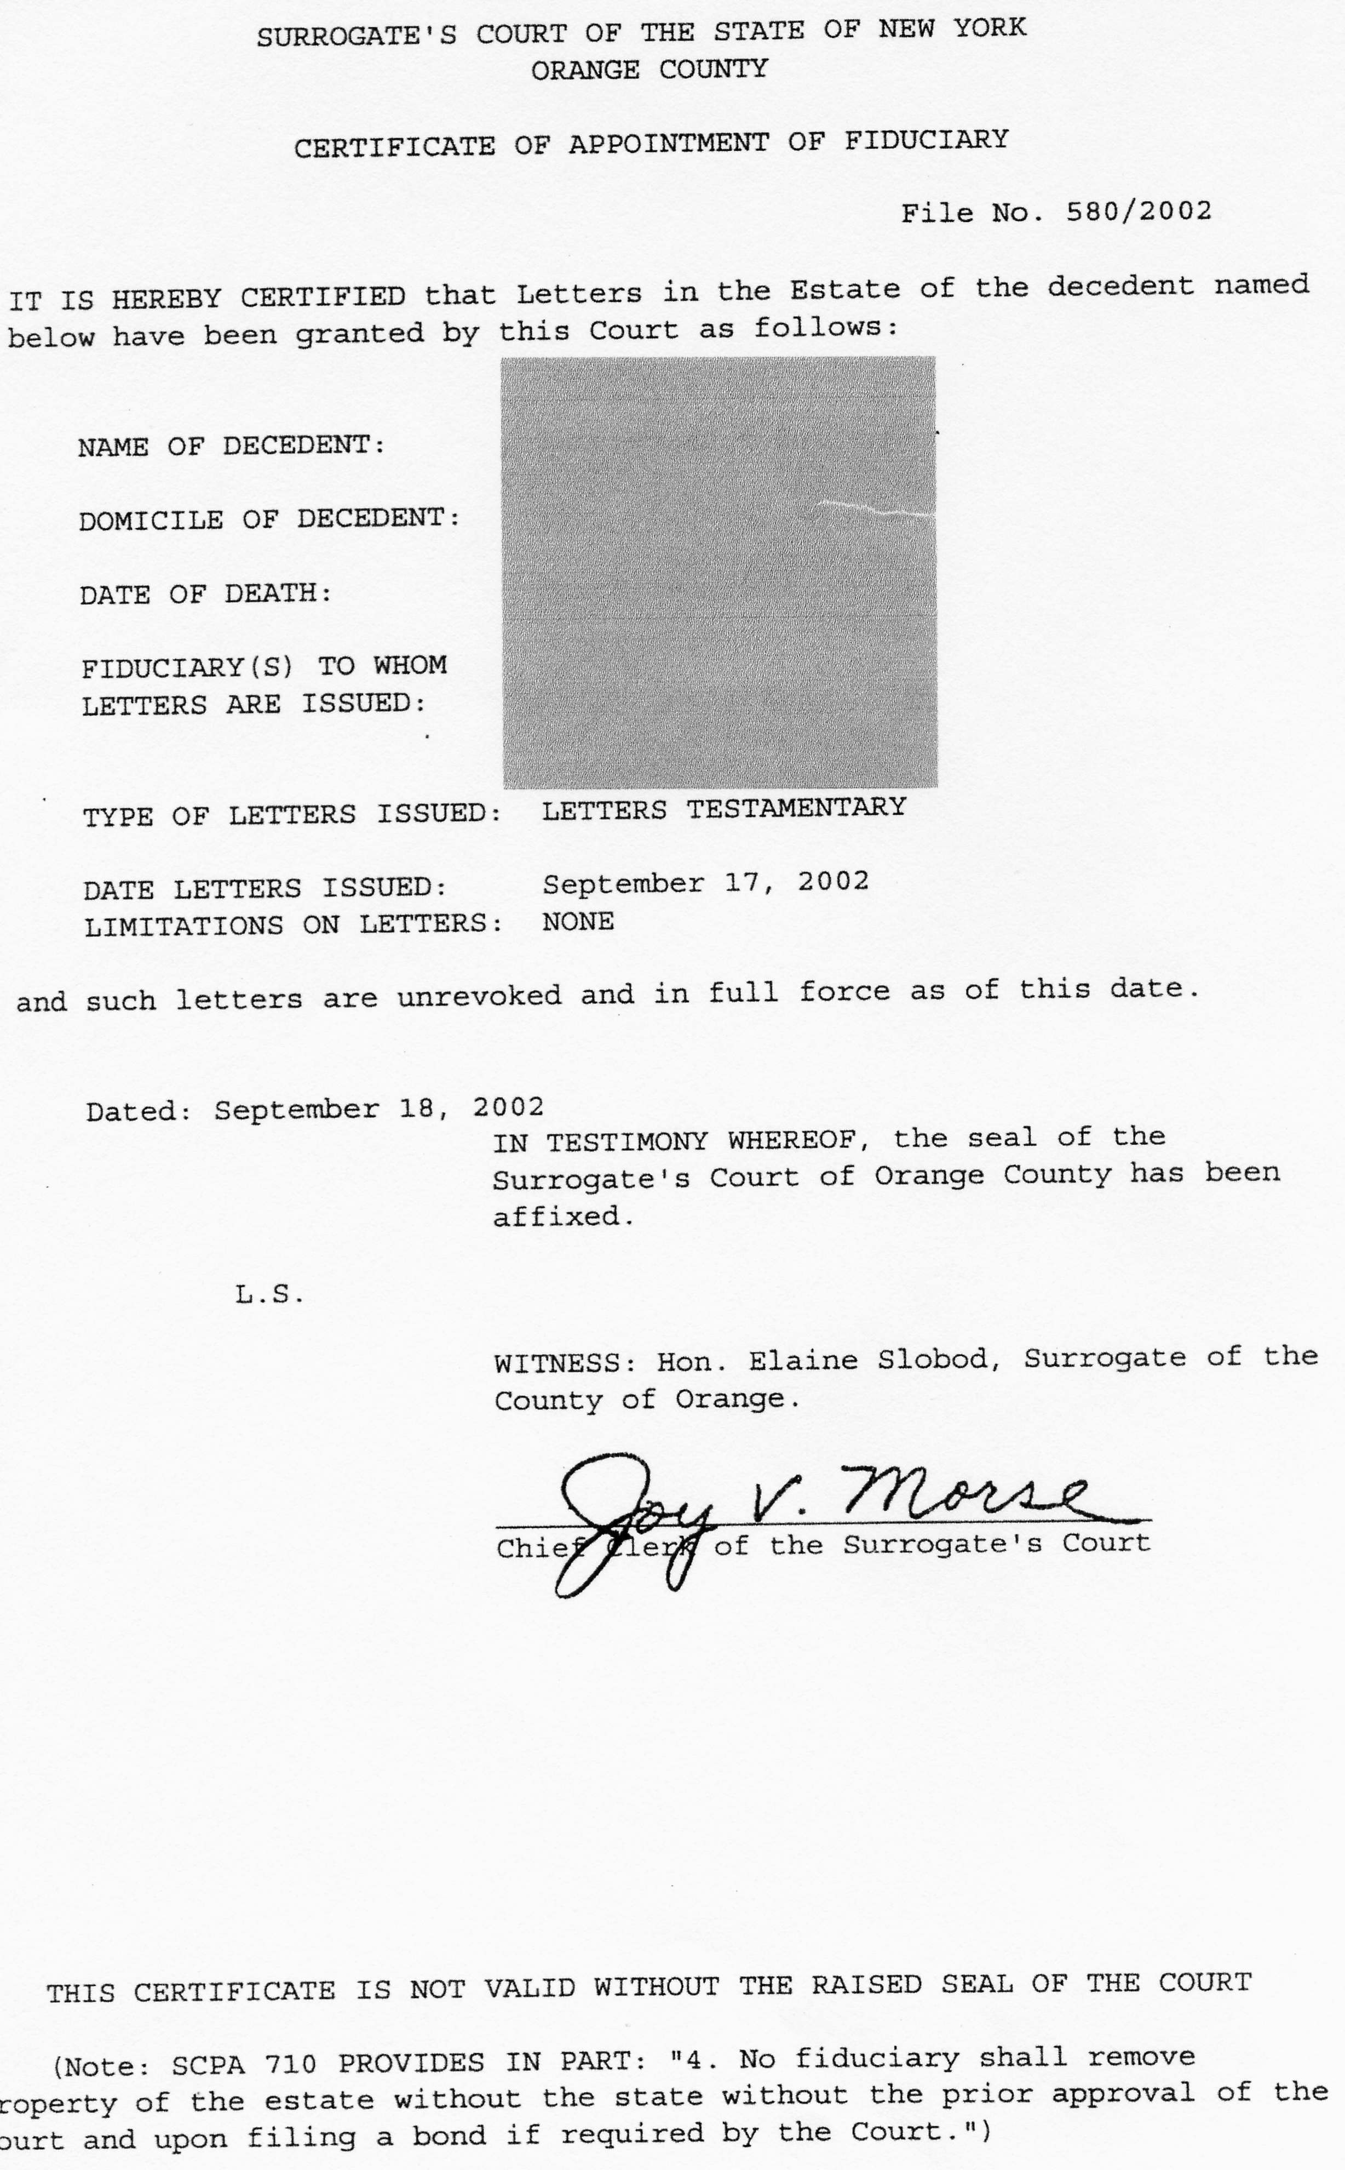
Ancillary Letters Testamentary



